|  |
| --- |
| Serpent Games Inc. |
| Super Snake 2020 |
| **“Cull the mouse population”** |
| Version #1.0  All work Copyright © 2020 by Serpent Games.  All rights reserved. |
| **Charles Thomson**  **Liping Wu**  **Zidane Drozario**  **Xinglong Lu** |
|  |

|  |
| --- |
| May 16th 2012 |

**Table of Contents**

**Version History** **3**

**Game Overview** **4**

**Game Play Mechanics** **4**

**Camera** **4**

**Controls** **4**

**Saving and Loading** **4**

**Interface Design** **5**

**Menu and Screen Descriptions** **5**

**Levels** **8**

**Characters** **8**

**Non-player Characters** **8**

**Enemies** **9**

**Items** **9**

**Scoring** **10**

**Sound Index** **11**

**Art / Multimedia Index** **11**

**Future Features** **12**

# Version History

Version_1.0: Made start page, play page, and game over page. Basic graphics were made, move area and stage bound were decided, and snake head had basic movement.

Version_1.1: Added mice, bomb function. Score system was implemented. Snake head got keyboard control function.Collision detection system was finished.

Version_1.2: Added snake body function, and graphics of snake were implemented. Upgraded timer system and grid system. Fixed all the bugs for collision detected, and checkbound. Upgraded level system.

Version_2.0: Reconstruct component position in stage. Added thorns wall to limite snake move area. Upgraded grid system. Added instruction at bottom of stage. Added snake collision function for itself.

Version_2.1: Rebuilt bomb function, and added more bombs and fixed their position. Number of bombs can be increased along with level upgrade. Added life system for game, snake can have 3 lives and it can increase life by eating collections. Added speed shoe function, snake can change its speed by eating different shoes.

# Game Overview

The goal of Super Snake 2020 is to control the snake to eat the mice in order to achieve the required score. When the score has reached the target score for each level, the game moves to the next level. Players can win the game if they complete all 5 levels, and if they lose all their lives, then it’s game over.

# Game Play Mechanics

Players need to control the snake’s movement to avoid dangerous elements such as bombs, eagles, thorned walls and the snake’s own body. At the same time players need to get as high a score as they can by eating mice and collecting coins.

# Camera

The game adopts a fixed overview of the game stage.

# Controls

Players can use arrow keys or W, A, S, D to control the snake’s movement.

Also, in the start page, players can click the start button to start the game. In the game over page, players can click the replay button to start again from the beginning, or click the main page button to move back to the start page.

There is no mouse control in the game.

# Saving and Loading

Players are not able to save their progress. There are no loading screens.

# Interface Design

The game’s interface features a main rectangular playing field, with a hud at the top and instructions at the bottom.

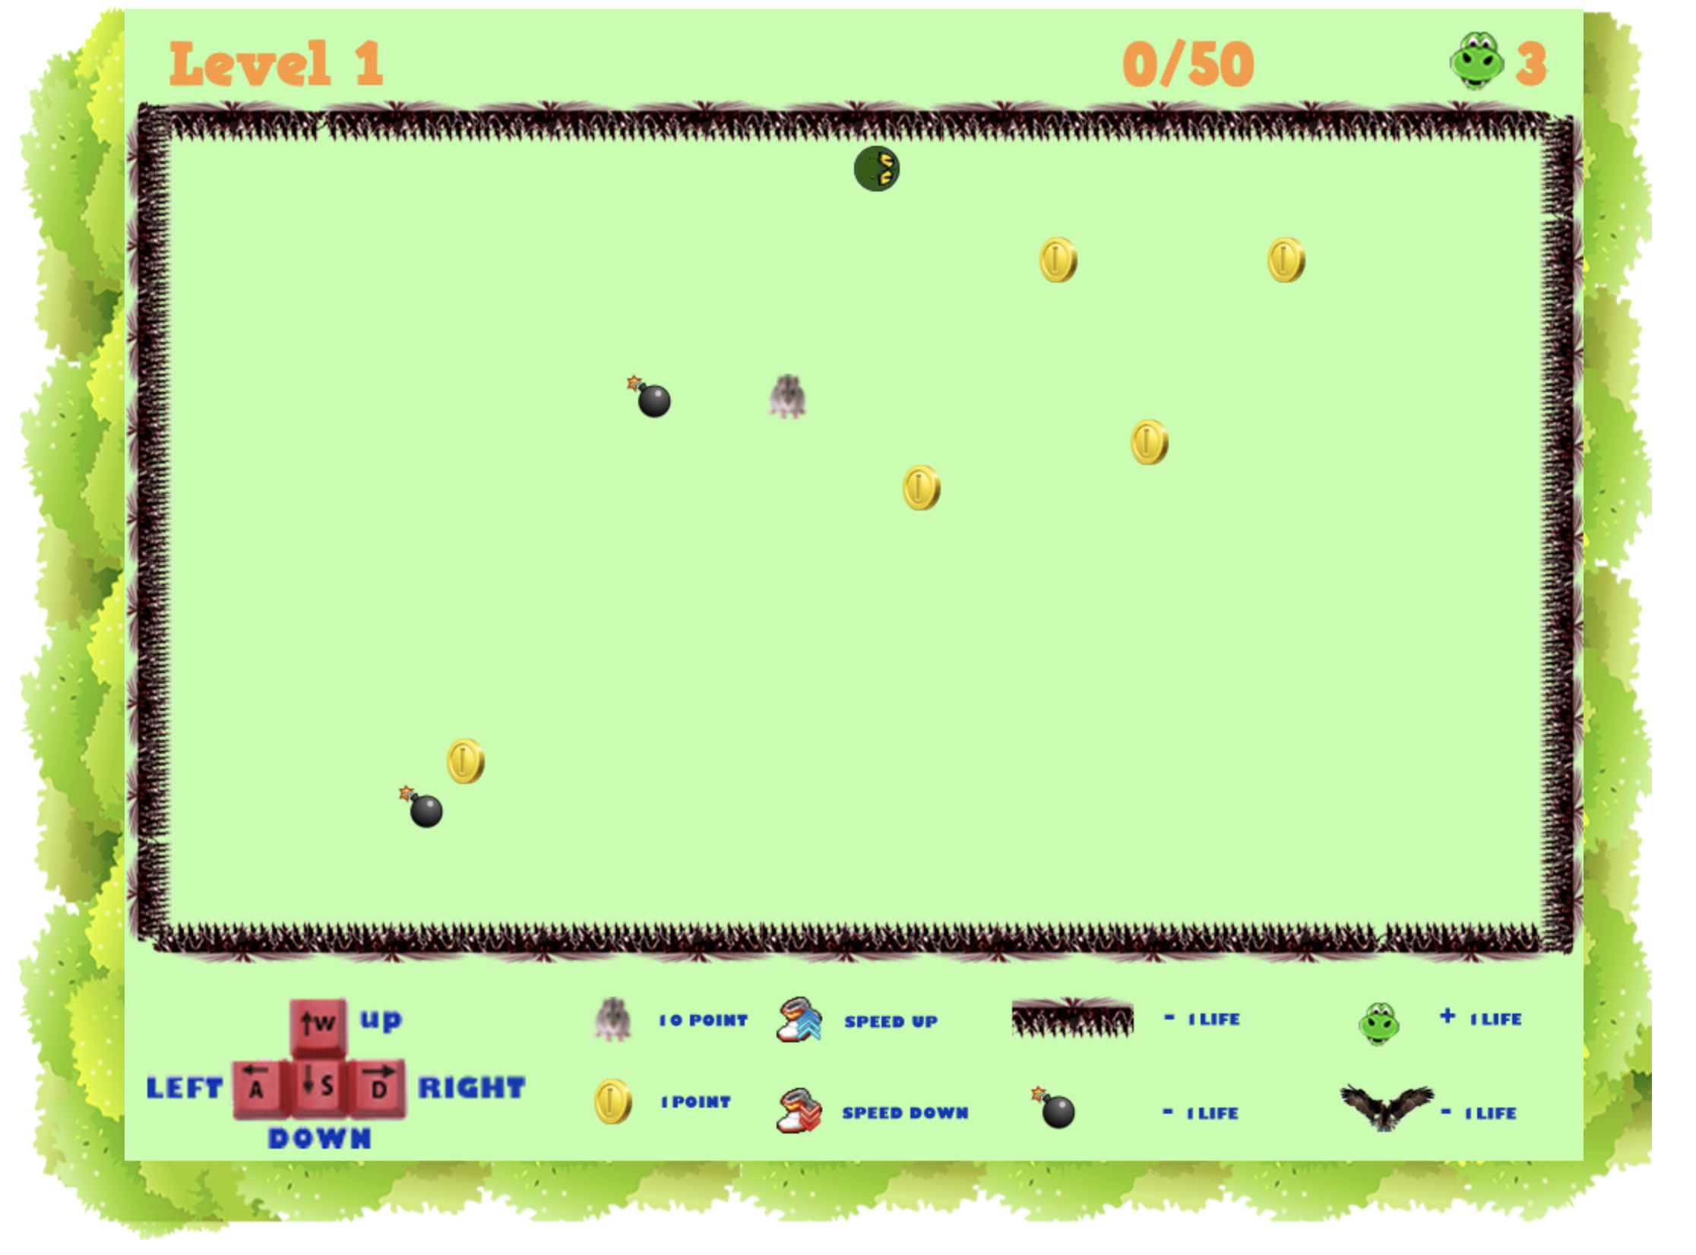

# Menu and Screen Descriptions

Start page (first screen to greet the player)

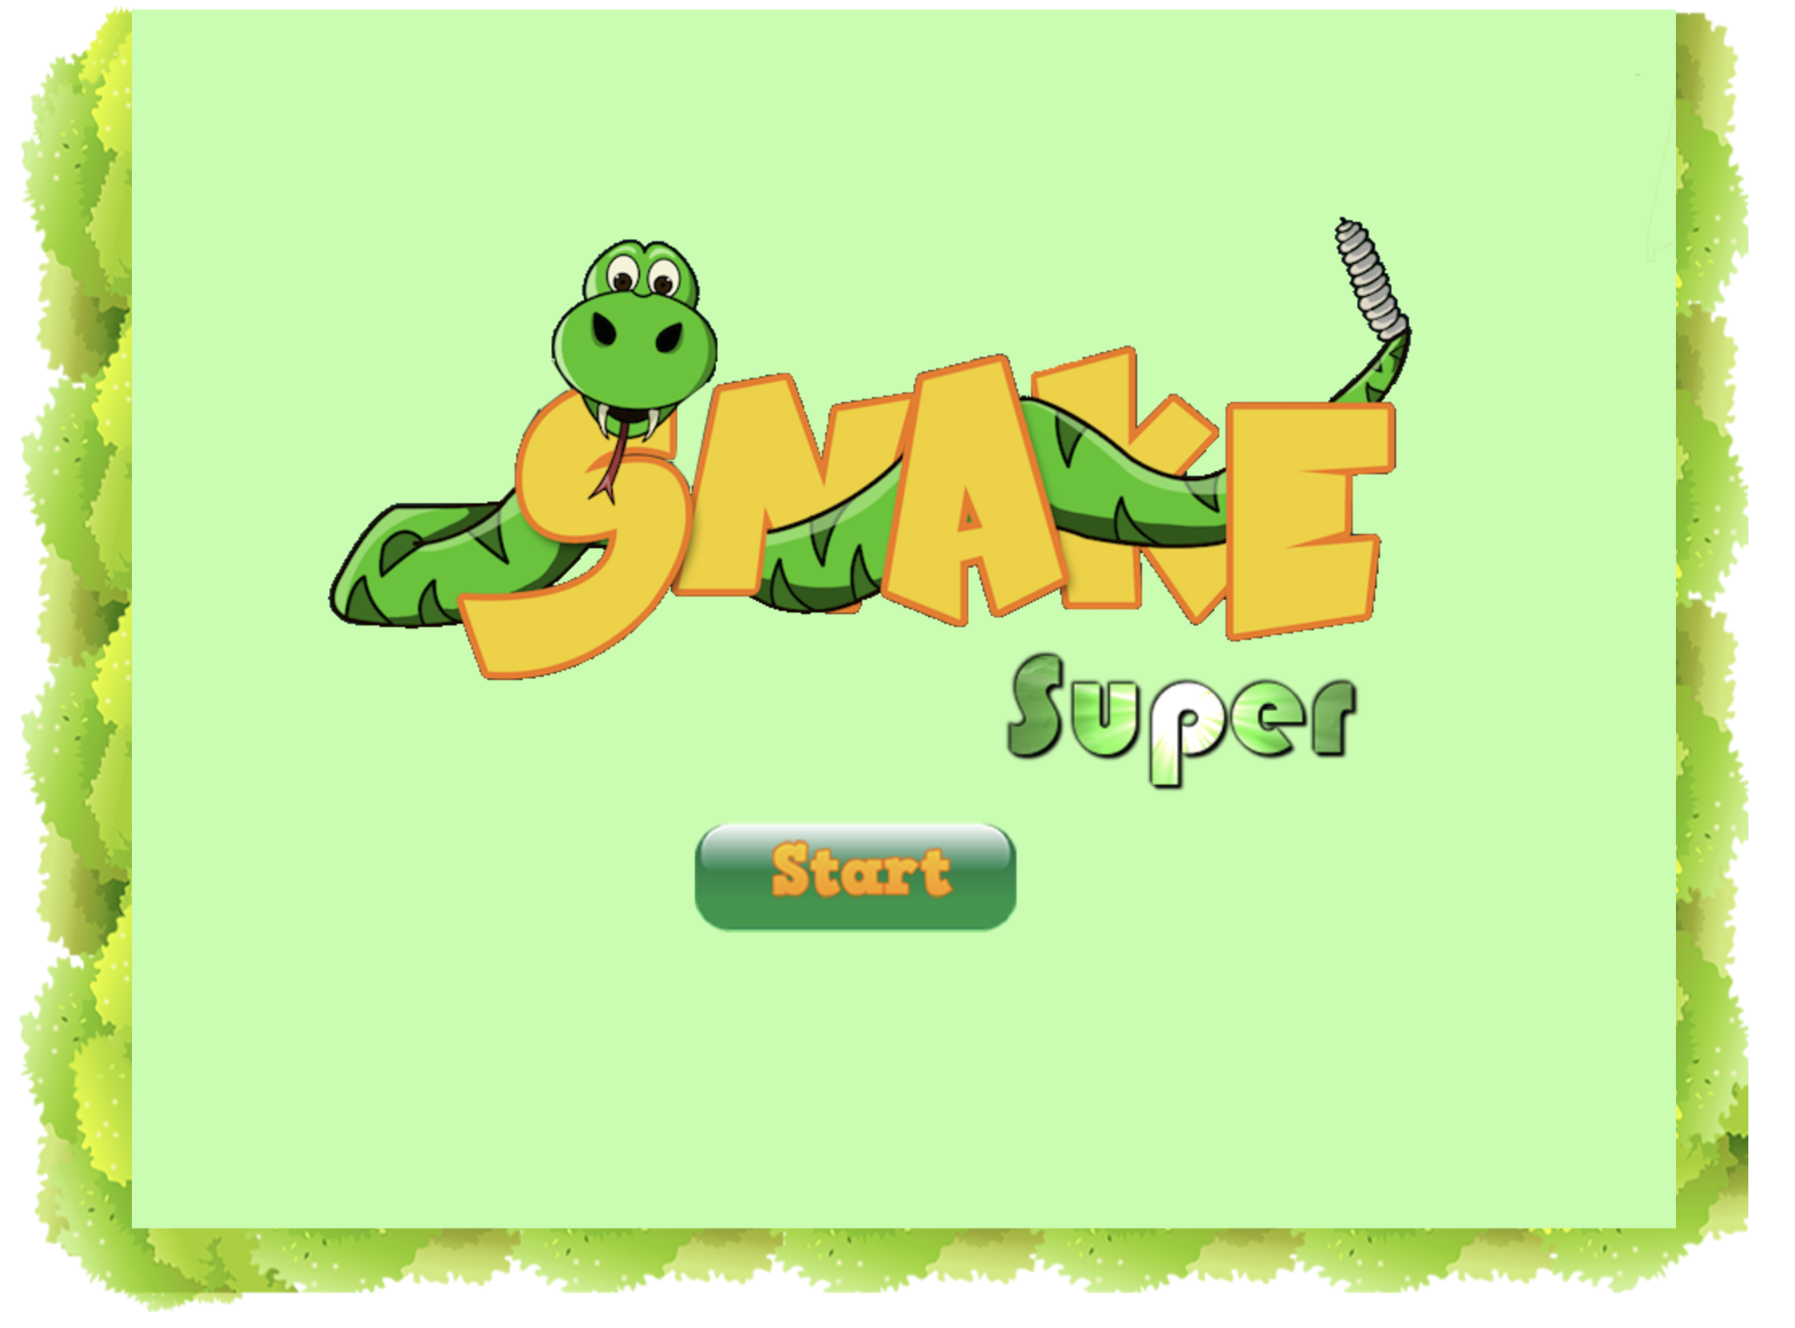

Game over page (screen shown when the player runs out of lives)

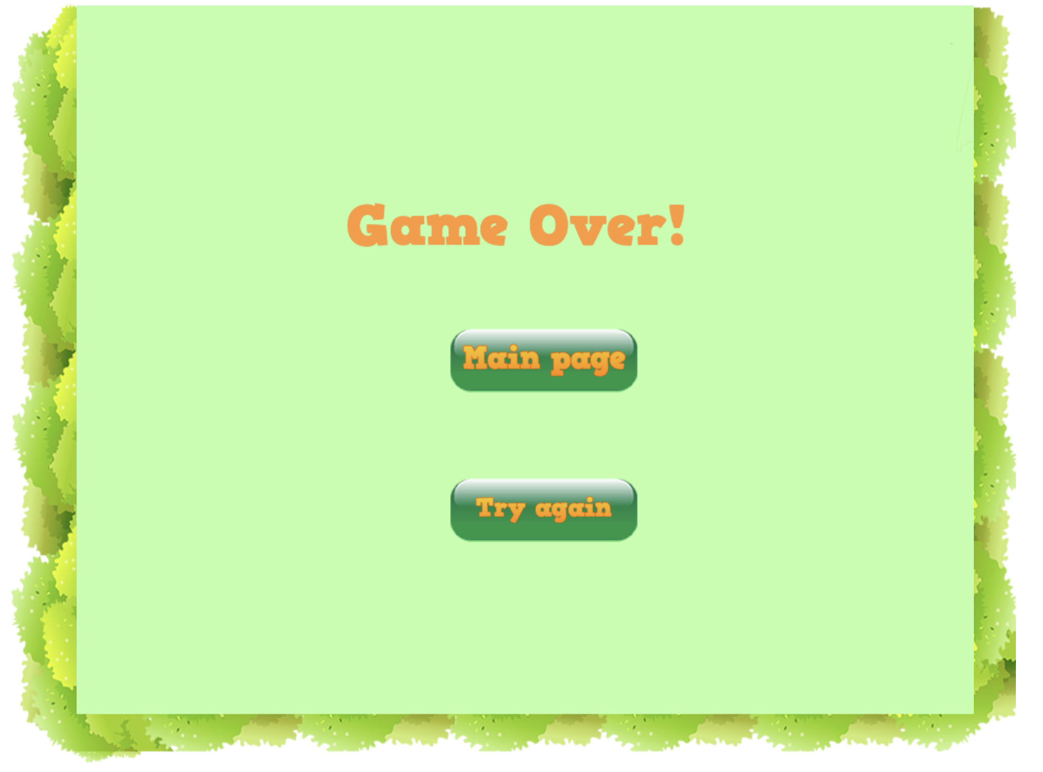

Win page (screen shown after the player completes the final level)



# Levels

The below table is an outline of the elements of each level.

|  |  |  |  |  |  |
| --- | --- | --- | --- | --- | --- |
|  | Level 1 | Level 2 | Level 3 | Level 4 | Level 5 |
| Target Score | 50 | 80 | 100 | 140 | 200 |
| No. of Bombs | 2 | 3 | 4 | 5 | 6 |
| No. of Eagles | 0 | 0 | 1 | 2 | 3 |
| No. of Lives | 0 | 1 | 1 | 1 | 1 |
| No. of SpeedShoes | 0 | 0 | 1 | 2 | 2 |
| No. of Coins | 5 | 5 | 10 | 10 | 10 |

When the player completes the fifth and final level, they win the game.

# Characters

**Snake**

The titular character who likes nothing better than to eat mice, avoid bombs and take long walks on the beach.



# Non-player Characters

**Mice**

They’ve multiplied like crazy and are a target for the hungry snake. They’re known for being furry, smelly and pro-cheese.

Adds 10 points when touched.



# Enemies

**Bombs**

Will explode when touched. Highly dangerous.

Snake will lose a life when touched.



**Eagles**

They fly through the sky looking to grab the snake whenever they can.

Snake will lose a life when touched.



# Items

**Coins**

Collecting one increases Snake’s points by 1.



**Lives**

Snake can collect extra lives to help avoid a game over.



**Speed Up Shoe**

Speeds up Snake temporarily, but depending on the player, this can be an advantage or a hindrance.



**Speed Down Shoe**

Slows Snake down temporarily, allowing the player to take their time in controlling Snake.



**Thorned Wall**

A wall surrounding the play area that will take away a life if Snake touches it.



# Scoring

1 Coin = +1 point

1 Mouse = +10 points

Once the player reaches the level’s target score, they complete the level.

* See “Levels” section for target scores.

# Sound Index

* Sound assets are in the Assets folder.

|  |  |  |
| --- | --- | --- |
| **Sound** | **Usage** | **Filename** |
| Explosion | When touching bombs | Explosion+3.wav |
| Game Over | When the game over page is shown | GameOverScreenSound.mp3 |
| Title Page | When the title page is shown | HomeScreenSound.mp3 |
| Level Complete | When a level’s target score is achieved | Level-complete-sound-effect.mp3 |
| Eat mouse | When Snake eats a mouse | snake_eatmice.wav |
| Eagle hit | When Snake hits an eagle | snake_hitsEagle.wav |
| Wall hit | When Snake hits the thorned wall | snakehitWall.wav |
| Collect coin | When Snake collects a coin | snakeHitCoin.wav |

# Art / Multimedia Index

* Graphic assets are in the Assets folder.

|  |  |
| --- | --- |
| **Graphic Asset** | **Filename** |
| Start button | StartBtn.png |
| General background | background.png |
| Thorned wall | thornsWall.png |
| Instructions below play area | instruction.png |
| Game logo | SnakeLogo-Background.png |
| Snake’s head | snakeHead.png |
| Snake’s body (one piece) | snakeBody.png |
| Mouse | mouse.png |
| Bomb | bomb.png |
| Speed up shoe | speedUpShoe.png |
| Speed down shoe | speedDownShoe.png |
| Collectable life | life.png |
| Collectable coin | coin.png |
| Life icon for hub | lifeIcon.png |
| Explosion for bomb | explosion.png |
| Thumbs up symbol for level completion | thumbsUp.png |
| Go back to start page button | MainPageBtn.png |
| Replay button | TryAgainBtn.png |
| Eagle | eagle.png |
| Eagle having caught Snake | eaglecatchsnake.png |
| Snake dead having eaten himself | snakeDead.png |

# Future Features

Currently various new features are being considered and will be released in due course. Downloadable content is set for release in Summer 2021.